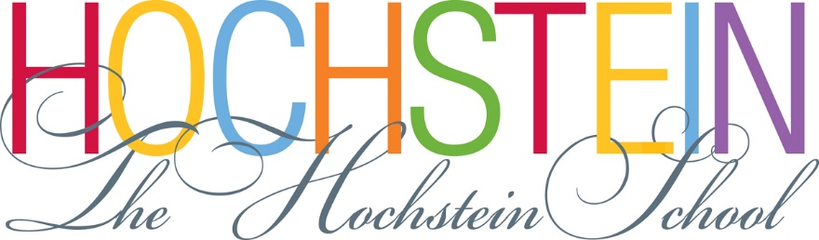

The David Hochstein Memorial School of Music & Dance
50 North Plymouth Avenue
Rochester, New York 14614

Part-Time POSITION AVAILABLE: Payroll & A/P Specialist & Data Manager

The successful candidate will have:
- Associates degree or higher in Accounting
- Proficient in Microsoft Office Excel & Word and 10-key by touch
- Experience with QuickBooks
- At least 2 years of related experience
- Excellent attention to detail, high degree of accuracy
- Excellent, professional communication skills, oral and written
- Helpful, enthusiastic attitude
- Able to work as part of a team in a fast-paced environment
- Trustworthiness; reliability; flexibility
- Ability to prioritize and carry out duties with minimal supervision
- Ability to meet deadlines
- Interest in Hochstein mission

Duties: Bi-weekly payroll input, including tally of faculty and staff timecards, other entries and adjustments as needed in payroll system; prepare invoices for approval, enter invoices into QuickBooks and filing; reconciling credit card statements with corresponding receipts; collect attendance, mileage, timesheet, and schedule information from the Expressive Arts Department’s therapists; process data to create payroll, mileage reimbursement, and statistics reports; document session dates, cancellations, make-ups, extra sessions, etc. and coordinate with Accounts Receivable staff for billing purposes; assistance with other Business Office functions as needed; other duties as assigned by the Business Manager and/or President/Executive Director.

Regular Hours: 24 hours per week – Monday, Tuesday, Wednesday & Thursday 9:00am – 3:00pm. Hours and days may be adjusted according to the seasonal or other needs of the School.

Wage Range: $12.75-$13.75/hour, depending upon qualifications and experience.

Position available immediately. The position will remain open until filled.

To Apply: Please email or fax (NO CALLS PLEASE) cover letter and resume to:

The Hochstein School of Music & Dance
ATTN: Yolanda Kelley, Business Manager
Email – yolanda.kelley@hochstein.org Fax – (585) 454-4393

The Hochstein School provides music and dance instruction and arts therapy services to individuals of all ages, levels, abilities, and backgrounds, regardless of financial means. Each year more than 3,500 children, youth, and adults participate in lessons, classes, and ensembles taught by an exceptional 110-member faculty.
June 2019

