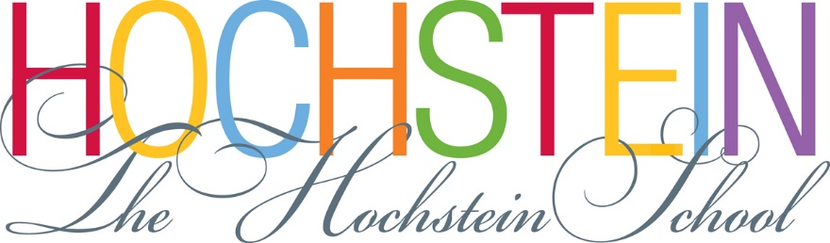

Position Available: Development Assistant (Full-time)
The Hochstein School seeks an enthusiastic and detail-oriented Development Assistant to assist the School’s Director of Development & Community Engagement with various systems and functions related to fundraising and friend-raising in support of the School’s mission and programs.

Major responsibilities include:
- Record gifts, submit deposits, and produce acknowledgements to donors
- Manage and maintain donor/friend/alumni databases
- Assist in implementation of multiple fundraising campaigns
- Provide organizational and logistical support for special events
- Produce regular reports to the School’s President, Director of Development & Business Office
- Track, acknowledge, and report Gifts in Kind
- Send pledge reminders
- Work with other staff on list development, reports, and gift reconciliation
- Other duties as assigned by the Director of Development and/or the President/Executive Director

Schedule: Generally Monday-Friday during business hours (9am-5pm), with one hour unpaid lunch. From time to time, schedule may be adjusted to assist with special events that occur on weekday evenings or weekends.

Qualifications:
- Bachelor’s degree with at least 1 year of administrative/professional experience required (college internships and participation in programs like AmeriCorps VISTA may be counted)
- Flexibility, persistence, attention to detail, and high degree of accuracy
- Strong computer skills in databases, Microsoft Office Suite, and high proficiency in Excel
- Demonstrated ability to work at a fast pace and manage multiple projects concurrently
- Outstanding oral and written communication skills
- Excellent customer service skills and attitude; friendly, accessible temperament and sense of humor
- Problem-solving, innovation, efficiency; knowledge of work flow systems a plus
- Ability to handle sensitive and confidential information appropriately

Compensation: $14-16/hr. based on experience (35 hours/week); health insurance and other benefits.
Position available immediately.

To apply: please submit letter of interest, résumé, and contact information for 3 current references to:
Cynthia Pacia, Director of Development & Community Engagement
The Hochstein School
50 N. Plymouth Ave., Rochester, NY 14614
Or via email to: Cynthia.Pacia@hochstein.org July 2019

